Control Engineering

Handout – Online Laboratory 6

Name: *Colda Andreea Ariana*

Group: *30332*

For the process described by



and the performance indicators

a)  respectively b) 

Following the steps described above, design a PD and a PID controller. Simulate the output of the closed loop for a step and ramp input to highlight the performance indices.

a)

*Add the obtained PD controller here.*

*0.7755 s + 1.551*

*Hr_PD = ----------------*

*0.3224 s + 1*

*Add Bode diagrams for both Hf and the open loop system (on the same plot).*

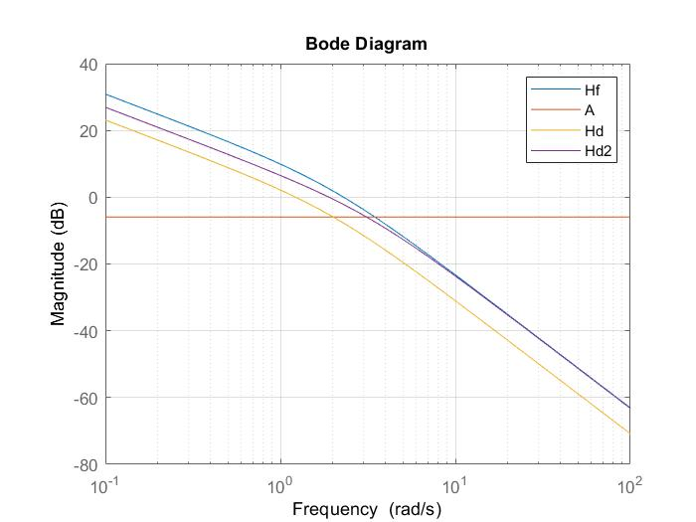

*Add graphical proofs of performance, step and ramp responses.*

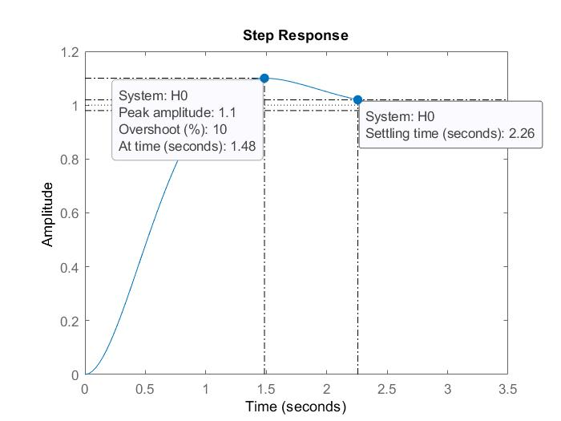

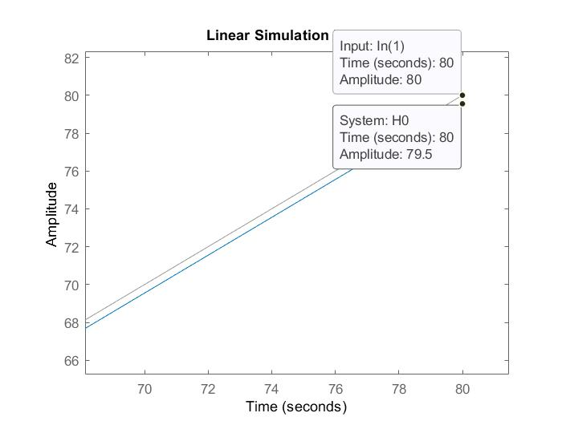

b)

*Add the obtained PID controller here*

*64.189 (s+0.5249)*

*Hd_PID = ----------------------*

*s (s+11.05) (s+0.4315)*

*Add Bode diagrams for both Hf and the open loop system (on the same plot).*

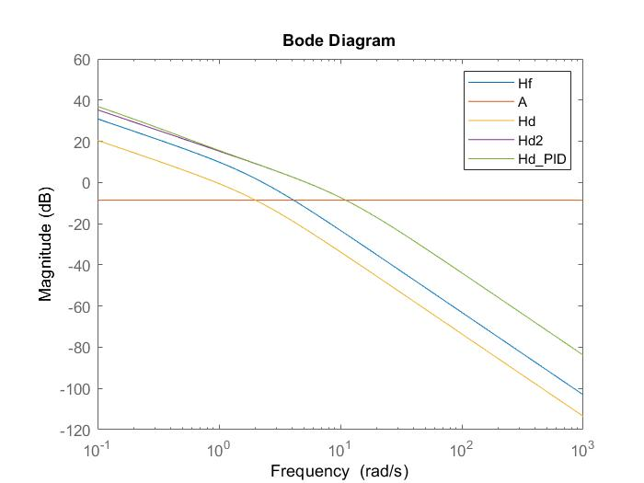

*Add graphical proofs of performance, step and ramp responses.*

